Experiment No. 6

Title: Understanding and Connectivity of RaspberryPi/Beagle board with Camera. Write an application to store and capture the image.

Aim: To understand the connectivity of Camera and store the image with Raspberry Pi Board.
Demonstrate a smart traffic system using Raspberry Pi and Python.

Hardware Requirement:
- Raspberry Pi Kit
- The Raspberry Pi Camera Module v2 has a resolution of 5 megapixel and has a fixed
focus lens onboard.
- The camera is capable of 2592 x 1944 pixel static images

Software Requirement: Raspbian O.S, Python.

Theory:

Raspberry Pi Camera Module
- The Raspberry Pi Camera Module v2 replaced the original Camera Module in April 2016.
- The v2 Camera Module has a Sony IMX219 8-megapixel sensor (compared to the 5-megapixel OmniVision OV5647 sensor of the original camera).
- The Camera Module can be used to take high-definition video, as well as stills photographs. It’s easy to use for beginners, but has plenty to offer advanced users if you’re looking to expand your knowledge.
- You can also use the libraries we bundle with the camera to create effects.
- You can read all the gory details about IMX219 and the Exmor R back-illuminated sensor architecture on Sony’s website, but suffice to say this is more than just a resolution upgrade: it’s a leap forward in image quality, colour fidelity, and low-light performance.
- It supports 1080p30, 720p60 and VGA90 video modes, as well as still capture. It attaches via a 15cm ribbon cable to the CSI port on the Raspberry Pi
- The camera works with all models of Raspberry Pi 1, 2, and 3.
- It can be accessed through the MMAL and V4L APIs, and there are numerous third-party libraries built for it, including the Picamera Python library.
- The camera module is very popular in home security applications, and in wildlife camera traps.

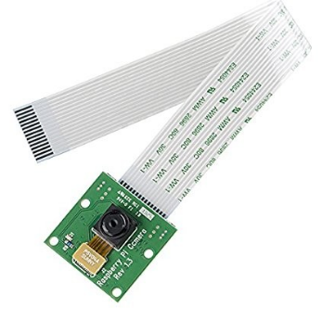

Steps to install the Pi Camrea:

1)Go to Preferences
2)Open RaspberryPi configuration.
3)Configure Raspberry Pi system.
4)Enable the camera Interface as shown in the diagram.

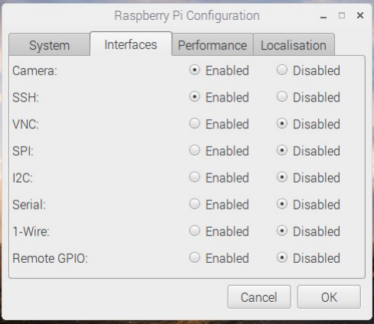

Code:
import picamera
from time import sleep
camera = picamera.PiCamera()
camera.capture('image1.jpg')
sleep(5)
Conclusion: We have successfully captured and stored the image using Raspberry Pi.

